
Lehigh Cycling
Proudly presents
The 2011 Lehigh University Mountain Top Classic
September 17 & 18

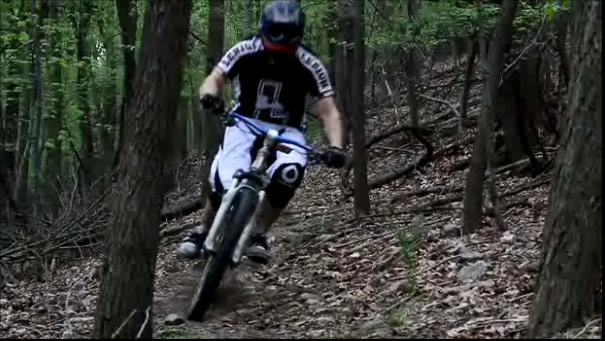




Promoter: Thomas Surgent
Email: tms212@lehigh.edu
Phone: (610) 291 - 0277
Schedule

Saturday, September 18th

8:00 am Registration opens at Iacocca Hall
8:00 am DH and XC practice open
8:30 am XC Intro Clinic
9:00 am Men’s C XC [ 1 lap ]
To follow (approx. 9:05 ) Women’s B [ 1 lap ]
To follow (approx. 10:15) Men’s A XC [ 3 laps ]
To follow (approx. 10:20) Men’s B XC [ 2 laps ]
To follow (approx. 10:25) Women’s A XC [ 2 laps ]
1:00 pm Cluster Huck Relay
2:00 pm DH start (all categories): Includes Open Category
-Order: Men’s C, Men’s B, Men’s A, Men’s A, Women’s A and Women’s B and Open Category

Sunday, September 19th

7:00 am Registration opens at South Mountain parking
8:00 am XTXC Intro Clinic
8:30 am Men’s C STXC [ 20 min ]
To follow (approx. 8:50) Women’s B STXC [ 20 min ]
To follow (approx. 9:10) Men’s B STXC [ 25 min ]
To follow (approx. 9:35) Women’s A STXC [ 25 min ]
To follow (approx. 10:00) Men’s A STXC [ 35 min ]
To follow (approx. 10:35) Team Relay
1:30 pm DH start (all categories): Includes Open Category
-Order: Men’s C, Men’s B, Men’s A, Men’s A, Women’s A Women’s B and Open Category

Collegiate categories are open only to current, eligible students holding USAC Collegiate licenses. One-day and yearly collegiate and open licenses will be available at registration.

Registration and Fees
XC | $15
STXC | $11
DH | $15 per day
Bus Service | $5 per person, per day
Team Relay | $20 per team
Cluster Huck | $20 per team
T-shirt | $15
Day of registration fee | $5 per rider

Teams are encouraged to pre-register on bikereg.com. If this does not work, you may contact tms212@lehigh.edu for more options. Race numbers and all forms will be taken care of at the race registration, please allow time for this the day of. Pre-reg will be accepted no later than 10pm on Thursday, September 15th. Day-of registration will be available both days, with a $5 late fee per rider.

Course Descriptions

Cross Country (XC)
The course is approximately 6 miles in length. It starts atop Lehigh’s south mountain. The first ¼ mile is a fast downhill fire road, which turns quickly into a short technical single track climb. A long single track descent ensues, which is littered with rock gardens, small bridges, quick climbs and tight turns. The track continues to the bottom of the mountain, where a flowing single track section opens into a half mile fire road. This road leads into a blistering single track climb that continues up half the mountain, and dumps into a short semi-flat section of rock gardens. The final ascent includes a technical climb with switchbacks that seem to multiply each lap. Eventually you will see daylight, and return to the start

Short Track Cross Country (STXC)
The course is just shy of ½ mile in length. The start line is on a wide fire road with a gradual uphill grade. At the top of the incline, the course makes a hard left into a slalom-like downhill with fast winding turns and returns to the bottom of the fire road incline, where most of the passing will take place.

Saturday Downhill
The course begins in the parking lot near registration. A steep start leads into several rolling mounds and rocky hard-pack past a small kicker. Crossing under the power lines leads to a small rocky descent into a quick left and several berms. Men’s A and Open riders split off and ride a technical off-camber decent. Others cross under the power lines several more times leading to a steep descent into a wooden bridge rock gap with a right side go around. A berm leads to a quick fire road to the finish. Course time is 2.5 - 3 minutes.

Cluster Huck
The cluster huck relay is a Downhill and Cross Country rider team event. The XC rider starts at the top of Saturday’s downhill course and rides a quick decent followed by a grueling uphill back to the start of Saturday’s downhill. Riders tag hands and the DH rider runs an alternate course parallel to the Saturday DH course, which converges back to the DH course at the bottom.

Sunday Downhill
The Sunday Downhill begins at the top of a water tower near a Frisbee golf course. The course begins with a fast decent, followed by a hard left turn. The rider then faces a large ladder bridge dropping down onto rock face, a rider around is available. This is an excellent place for spectators to watch. The course then turns left again for some additional DH action. The course runs approximately 2.5 – 3 minutes.
Event Map and Directions

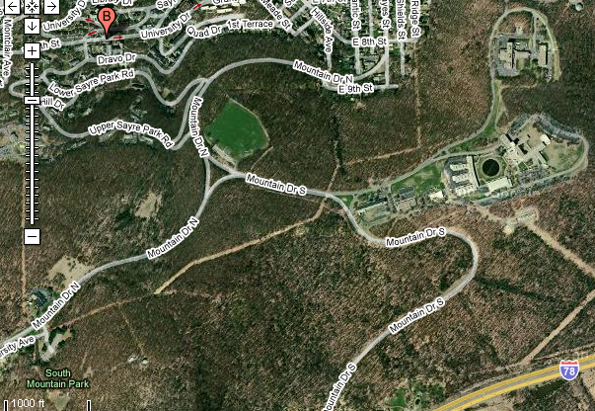
Sun. DH, STXC & Registration

Sat. Registration
XC
Sat. DH
*Signs will be posted from exit ramp of I-78 to race registration * red arrows to registration
Directions to Lehigh University Mountain Top Campus
- From New Jersey: Take I-95 to I-78 West and follow below
- From Philadelphia, PA: I-476 North to I-78 East and follow below.
- From NH/MA: Take I-90 West to I-84 West; follow to I-87 South, then take I-287 South to I-78 West and follow below
- From Upstate NY/VT: I-87 South to I-287 South, then I-78 West and follow below

From I-78, take exit 67. Go strait at ramp bottom onto Silvex Road. Pass through small tunnel, under I-78, and follow road to left at small “Y” intersection. Go strait through next stop sign and past Lehigh University Football Arena. Turn right at the “T” intersection onto Mountain Drive. Stay strait to summit of mountain.

Sat. Registration/Race: Iacocca Hall
111 Research Drive
Bethlehem, PA 18015

Sunday Registration/Race: South Mountain Park, Mountain Drive North

Link: to Google Maps http://maps.google.ie/maps?f=q&source=s_q&hl=en&q=mountain+top&sll=40.594729,-75.356512&sspn=0.034933,0.067463&ie=UTF8&t=h&split=1&rq=1&ev=p&radius=2.13&hq=mountain+top&hnear=&ll=40.599226,-75.359859&spn=0.034931,0.100164&z=14

Medical

EMS and Lehigh University Police will be on site for all races

Lodging

Hotels are available in nearby Bethlehem, PA

Limited space will be available in off campus housing with students around campus. Give me a call or send me an email and I will see what I can figure out.

Contact

Thomas Surgent
tms212@lehigh.edu
Surgentt@gmail.com
(610) 291 0277

Thanks to our sponsors!




